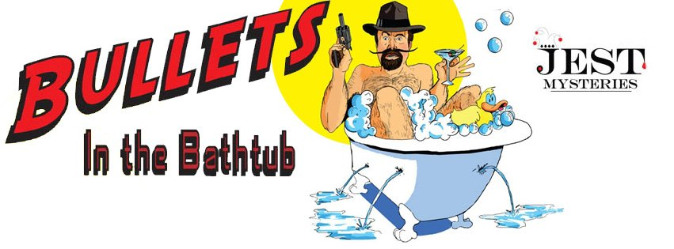

Members,

The Alexandria Bar Association secured Jest Murder Mysteries Co. to produce a virtual live performance for members. The theme is Bullets in the Bathtub.

THE GIST:
Welcome to the 1920s where bathtubs were made for one thing only.

To make gin! (Ok, maybe two things).

Lot's of gangsters show up at "Cherry’s Speakeasy” to talk about the turf war going on between the Corneolis and the Buttafuccos. Just when we think things are going to settle down, in comes Harry Hyde (the famous Russian mobster). He sure does know how to make enemies! Deadly ones!

I guess the local constable, Doyle Lonnegan, will come and solve the crime, but not before things get pretty wild!

You’ll meet crazy characters like Red E. Mix (the local concrete salesman), Trixie ( the owner of Cherry’s), and many others before we find out who put “da finger” on Harry’s Hyde! Was it Larry, The Rug? Was it Joey, The
Lips? Or maybe, J Edna Hoover?
When you come to “Bullets in the Bathtub.” don’t forget to bring your gangster hat, tommy gun, and flapper!

HOW IT WORKS:
You must register in advance for this virtual event (separate Zoom meeting): https://us02web.zoom.us/meeting/register/tZcqcOGtqD8rEtYnL4xlRCE1MJEBS72QQFza
Your link is generated and emailed to you after registering directly with Jest to join the show.
(using someone else's link will negatively impact the virtual event!)
Please visit Jest’s Virtual Show Tips Page for costume ideas, requirements, how-tos, and more! https://virtualmurdermysteryparty.com/show-info/bullets-info/

After the mixology presentation, log off of the Association link and click that link in the email you received from Jest. Once you are let into the virtual room, you’ll be automatically transported to “The Alley behind Trixie’s Speakeasy” (that’s where we are all meeting before the event!) Once there, you’ll receive the part you’ll be playing and can interact with your fellow audience members and our professional actors via the zoom chat.

The rest …is a mystery!

